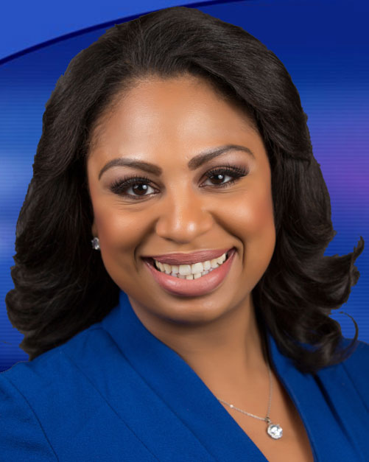

Experience

Reporter, NY1, New York, NY April 2018 – Present
- Shoot, write and edit packages
- Report packages and live shots in English and Spanish
- Enterprise multiple stories per week
- Update various social media platforms including live updates from the field
- Post stories and video to station’s website

Reporter, WJZ, Baltimore, MD March 2015 – March 2018
- Emmy nominated for General Assignment (2018) and Continuing Coverage (2016)
- Enterprise stories daily
- Reported live on TV
- Posted stories on social media and web several times a day
- Generated and maintained sources

Morning Live Reporter/MMJ, News 12 The Bronx, Bronx, NY July 2011 – March 2015
- Reported live from the field for the morning show and produced packages five days a week
- Shot, wrote and edited stories daily. Reported live in the field and in studio

Assignment Desk Editor/Field Producer, News 12 The Bronx, Bronx, NY August 2010 – July 2011
- Generated story ideas, set up interviews for field crews, researched stories
- Gathered elements for reporters including graphics, tapes, photos

Producer, Univision, New York, NY May 2010 – September 2010
- Produced live shots and packages. Conducted interviews

MMJ/Producer/Writer, CUNY TV, New York, NY August 2009 – December 2010
- Generated story ideas, gather information, and produce and present stories for all platforms

Education

City University of New York Graduate School of Journalism December 2010
Master of Arts in Journalism, concentration in urban reporting for broadcast media.

Hunter College, New York May 2007
Bachelor of Arts in English with a minor in political science.

Training
- Intern, News 12 The Bronx, Bronx, N.Y. (June-Aug. 2010)
- Intern, Univision, New York, N.Y. (Jan.-May, 2010)
- Mediabistro workshops: Introduction to Television News Reporting and Advanced Television (Winter 2008–2009)

Skills and Capabilities
- Bilingual in Spanish
- Software: ENPS, Final Cut Pro, Mac OS 10.4, Adobe Photoshop, ProTools, HTML, Web 2.0 Applications, WordPress, Lexis Nexis. Hardware: Sony PD170, digital SLR and flip cameras, Marantz 620 and 660.
- Social Media: Facebook, Myspace, and Twitter

Recognition
- Emmy nomination for General Assignment Report: Man Rescues people after explosion, (Reporter) 2018
- Emmy nomination for Continuing coverage within 24 hours: Freddie Gray Riots, (news cast) 2016

