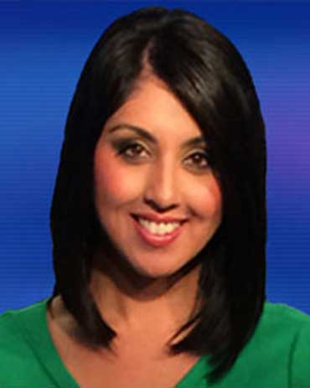

Experience

Investigative Reporter, KXAN, Austin, TX August 2016 – Present

Reporter/Fill-in Anchor, KTVT/TXA, Dallas, TX July 2008 – February 2016
- Enterprise stories regularly
- Cover multiple stories daily for a number of newscasts
- Responsible for breaking news & continuing coverage
- Regular fill-in on weekend morning newscasts

Cultural Consultant, United States Army September 2008 – September 2012
- Subject Matter Expert on Afghanistan
- Work with soldiers in the University of Foreign Military & Cultural Studies Program at Fort Leavenworth, KS & Camp Mabry, TX
- Provide analysis regarding ongoing U.S. & coalition operations in Afghanistan

Reporter/Fill-in Anchor, KTBC, Austin, TX May 2004 – June 2008
- Travel across state to perform live shots for Fox News Channel
- Enterprise exclusive stories regularly
- Responsible for investigative sweeps pieces

Reporter/Weekend Anchor, KZTV, Corpus Christi, TX August 2001 – April 2004
- Produce, write and perform live shots for 5, 6 and 10 pm newscasts
- Anchor and produce weekend newscasts
- Manage assignments desk

Education

University of Texas at Austin 2001
Bachelor of Journalism

Awards
- Lone Star Emmy Award for Reporting: Take A Stand Against Bullying 2013
- Texas AP Broadcasters Best Magazine/Special, First Place 2006
- Texas AP Broadcasters Best Reporter, Second Place 2005
- Texas AP Broadcasters Best Series, Honorable Mention 2005

Languages
- Fluent in Farsi
- Moderate knowledge of Pashto and German

